**ABHIJIT DASH**

**RA1811031010112**

**LEADING AND TRAILING**

**AIM:-**

To compute leading and trailing for a given grammar.

**CODE:-**

#include<iostream>

#include<string.h>

#include<conio.h>

using namespace std;

int nt, t, top = 0;

char s[50], NT[10], T[10], st[50], l[10][10], tr[50][50];

int searchnt(char a) {

int count = -1, i;

for (i = 0; i < nt; i++) {

if (NT[i] == a)

return i;

}

return count;

}

int searchter(char a) {

int count = -1, i;

for (i = 0; i < t; i++) {

if (T[i] == a)

return i;

}

return count;

}

void push(char a) {

s[top] = a;

top++;

}

char pop() {

top--;

return s[top];

}

void installl(int a, int b)

{

if (l[a][b] == 'f') {

l[a][b] = 't';

push(T[b]);

push(NT[a]);

}

}

void installt(int a, int b) {

if (tr[a][b] == 'f') {

tr[a][b] = 't';

push(T[b]);

push(NT[a]);

}

}

int main() {

int i, s, k, j, n;

char pr[30][30], b, c;

cout << "Enter the no of productions:";

cin >> n;

cout << "Enter the productions one by one\n";

for (i = 0; i < n; i++)

cin >> pr[i];

nt = 0;

t = 0;

for (i = 0; i < n; i++) {

if ((searchnt(pr[i][0])) == -1)

NT[nt++] = pr[i][0];

}

for (i = 0; i < n; i++) {

for (j = 3; j < strlen(pr[i]); j++) {

if (searchnt(pr[i][j]) == -1) {

if (searchter(pr[i][j]) == -1)

T[t++] = pr[i][j];

}

}

}

for (i = 0; i < nt; i++) {

for (j = 0; j < t; j++)

l[i][j] = 'f';

}

for (i = 0; i < nt; i++) {

for (j = 0; j < t; j++)

tr[i][j] = 'f';

}

for (i = 0; i < nt; i++) {

for (j = 0; j < n; j++) {

if (NT[(searchnt(pr[j][0]))] == NT[i]) {

if (searchter(pr[j][3]) != -1)

installl(searchnt(pr[j][0]), searchter(pr[j][3]));

else {

for (k = 3; k < strlen(pr[j]); k++) {

if (searchnt(pr[j][k]) == -1) {

installl(searchnt(pr[j][0]), searchter(pr[j][k]));

break;

}

}

}

}

}

}

while (top != 0) {

b = pop();

c = pop();

for (s = 0; s < n; s++) {

if (pr[s][3] == b)

installl(searchnt(pr[s][0]), searchter(c));

}

}

for (i = 0; i < nt; i++) {

cout << "Leading[" << NT[i] << "]" << "\t{";

for (j = 0; j < t; j++) {

if (l[i][j] == 't')

cout << T[j] << ",";

}

cout << "}\n";

}

top = 0;

for (i = 0; i < nt; i++) {

for (j = 0; j < n; j++) {

if (NT[searchnt(pr[j][0])] == NT[i]) {

if (searchter(pr[j][strlen(pr[j]) - 1]) != -1)

installt(searchnt(pr[j][0]), searchter(pr[j][strlen(pr[j]) - 1]));

else {

for (k = (strlen(pr[j]) - 1); k >= 3; k--) {

if (searchnt(pr[j][k]) == -1) {

installt(searchnt(pr[j][0]), searchter(pr[j][k]));

break;

}

}

}

}

}

}

while (top != 0) {

b = pop();

c = pop();

for (s = 0; s < n; s++) {

if (pr[s][3] == b)

installt(searchnt(pr[s][0]), searchter(c));

}

}

for (i = 0; i < nt; i++) {

cout << "Trailing[" << NT[i] << "]" << "\t{";

for (j = 0; j < t; j++) {

if (tr[i][j] == 't')

cout << T[j] << ",";

}

cout << "}\n";

}

getch();

}

**OUTPUT SCREENSHOT:-**

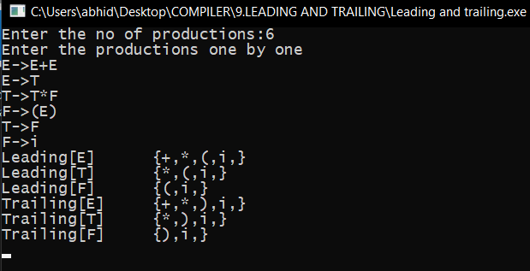

**RESULT:-**

Leading and Trailing has been calculated for the given productions.